306 East Madison, Gardner. Kansas 66030 Office: 913.856.4250

Dear Parents,

We are so excited to be able to offer Stretch-n-Grow at Open Arms. This opportunity is offered for all our full time classes from two year olds through PreK.
If you choose to have your child participate, the cost of the program is $3.00 which will be added to your weekly tuition.
Stretch-n-Grow is a great opportunity for your child to have a 30-minute fitness class right here on site! It’s like an in house field trip every week!!
Stretch-n-Grow is scheduled for each classroom during a regular break time that will not interfere with the instruction of the day. It is currently being held on Tuesdays.
We don’t hold Open Arms or SNG responsible for injury or illness related to exposure.

Sincerely,

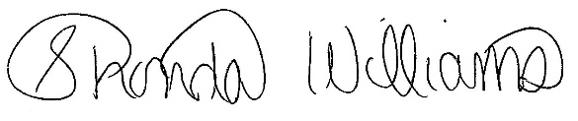
Shonda Williams, Director

Detach and Return

Child’s name Classroom

____I would like for my child to participate in the 30 min. Stretch-n-Grow class for $3 per class.

____I do not want my child to participate.

Parent Signature Date

